CIS423 - Web-based Systems

Final Project Report – Group C



Title: Malbasy - ملبسي

Group Information: CS, 8MS1, Group C.

Submitted to: Dr. Feras Altarouti.

Date Submitted: May 18th, 2022

|  |  |  |  |
| --- | --- | --- | --- |
| Leader | ID | Member Name | Email Address |
| ☺ | 2190005929 | Omar Alsantali | 2190005929@iau.edu.sa |
| € | 2190002994 | Khalid Alsantali | 2190002994@iau.edu.sa |
| € | 2190000220 | Badr Alkhaldi | 2190000220@iau.edu.sa |
| € | 2190003341 | Ali Alghamdi | 2190003341@iau.edu.sa |
| € | 2190005038 | Sakher Alroqi | 2190005038@iau.edu.sa |
| € | 2190001857 | Bandar Almutairi | 2190001857@iau.edu.sa |

# Introduction

Malbasy is a clothing e-commerce mock website made for the purposes of this course’s project. It is made with HTML, CSS & JavaScript (form validation) for the frontend, and PHP & MySQL for the backend & database.

# Task Distribution

Our team worked collectively to build Malbasy. All tasks were a collaborative effort with everyone contributing. However, the rough task distribution was as follows:

* Omar – Design & Backend
* Khalid – Admin logic & DB
* Badr – Frontend & UX
* Sakher – Frontend & UI
* Bandar – Error handling & Backend
* Ali – Layout & UI

# Database design

## ER Diagram

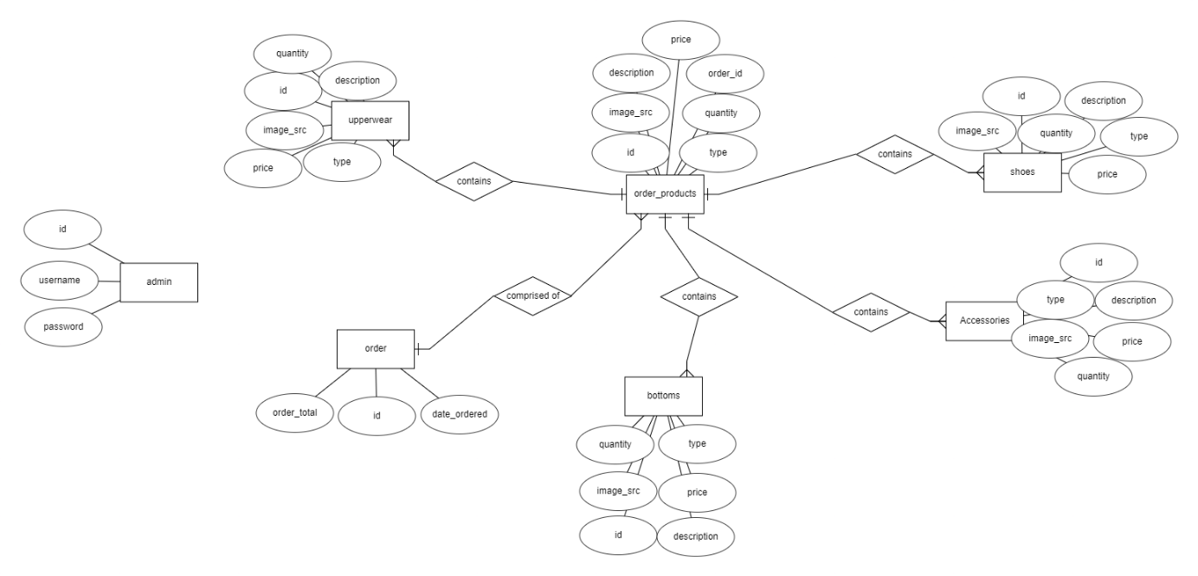

Figure 1 - ER Diagram for Database

Our ER diagram changed significantly between the last milestone and now. The main structure is mostly the same but we omitted some attributes from our different clothes tables. We also needed another table to help store orders and order details. We also omitted the user table in favor of storing some of that information session data. The structure is similar but small details have been changed.

## Tables

Figure 2 - Accessories Table

Figure 3 - Bottoms Table

Figure 4 - Shoes Table

Figure 5 - Upperwear Table

Figure 6 - Order Table

Figure 7 - Order_Products

Figure 8 - Admin Table

# Webapp Interfaces

This section will contain all the interfaces of Malbasy

**Homepage:**

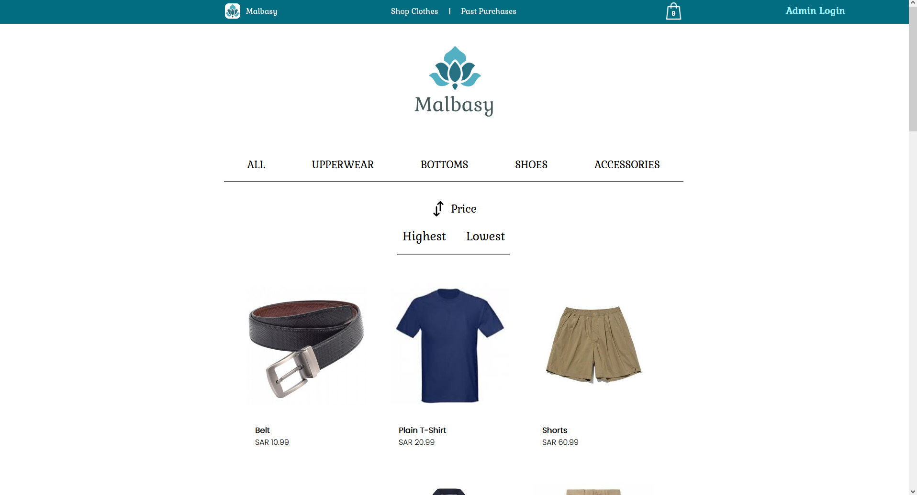

**Product Details:**

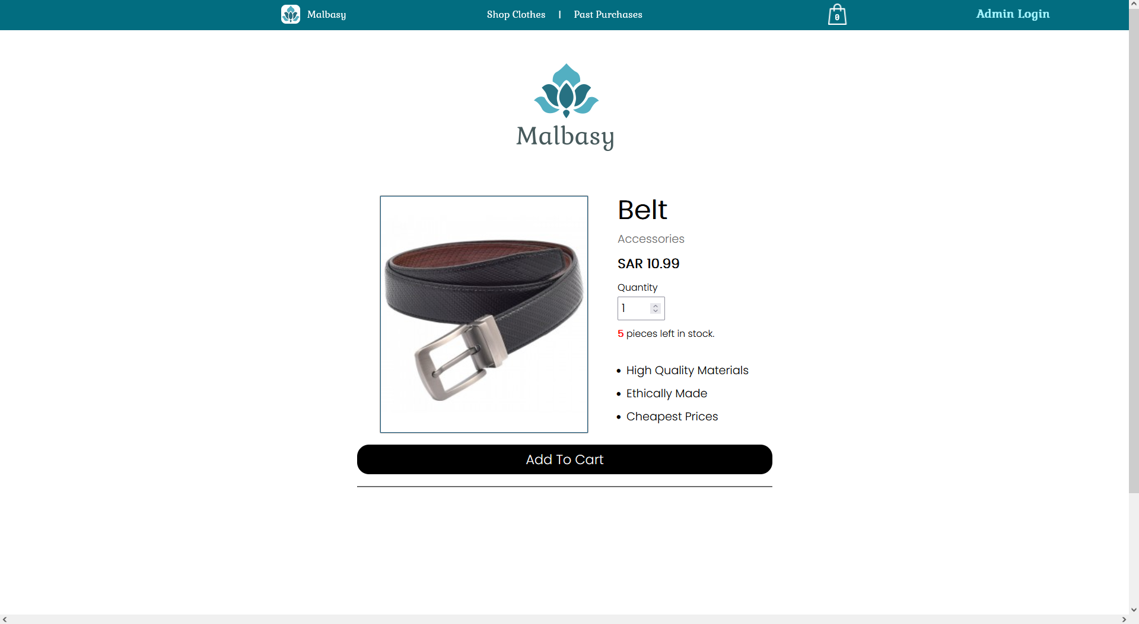

**Empty Shopping Bag:**

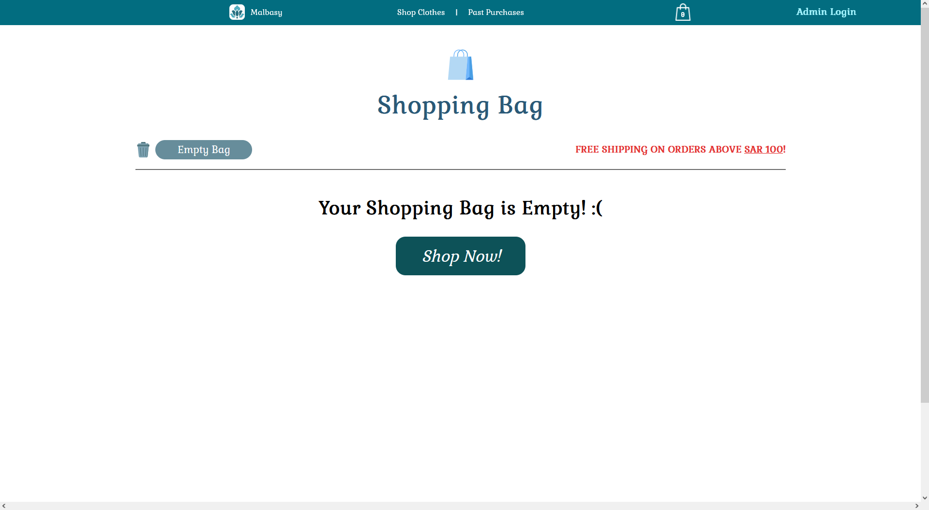

**Filled Shopping Bag:**

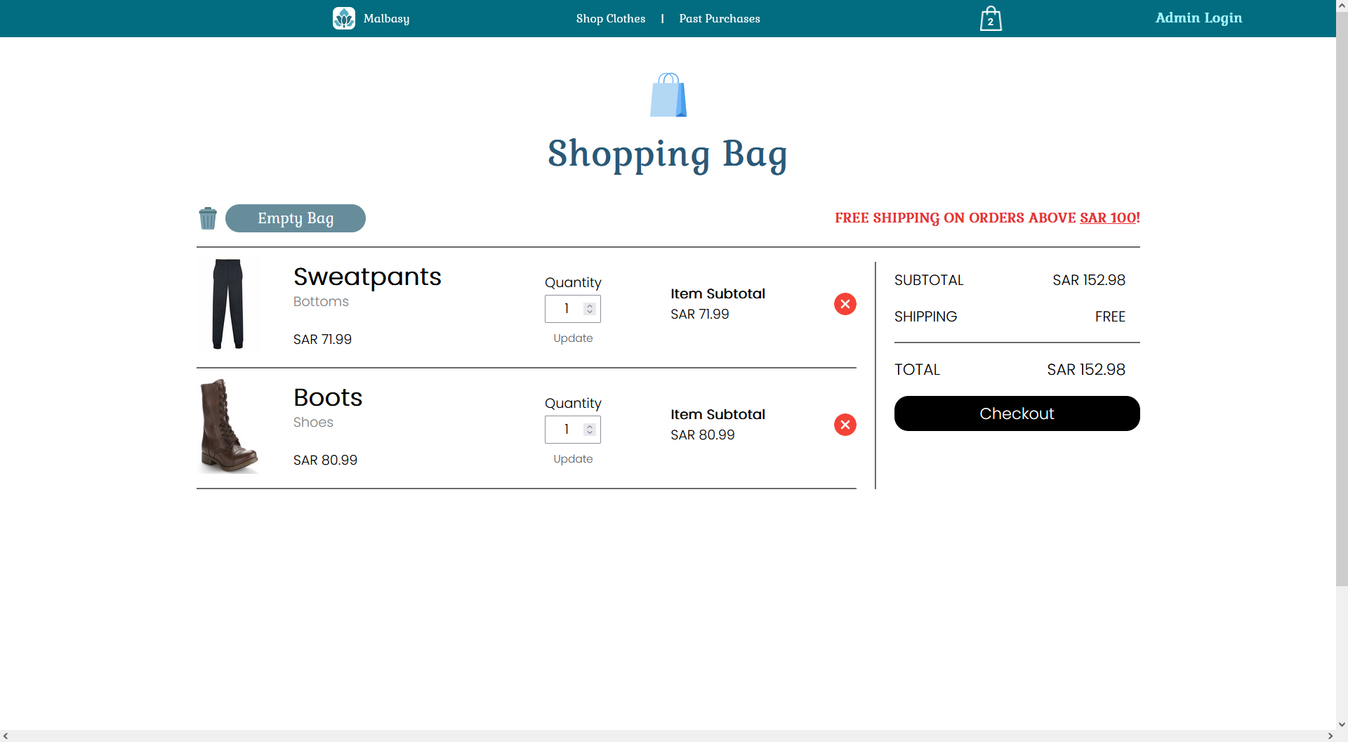

**Successful Purchase:**

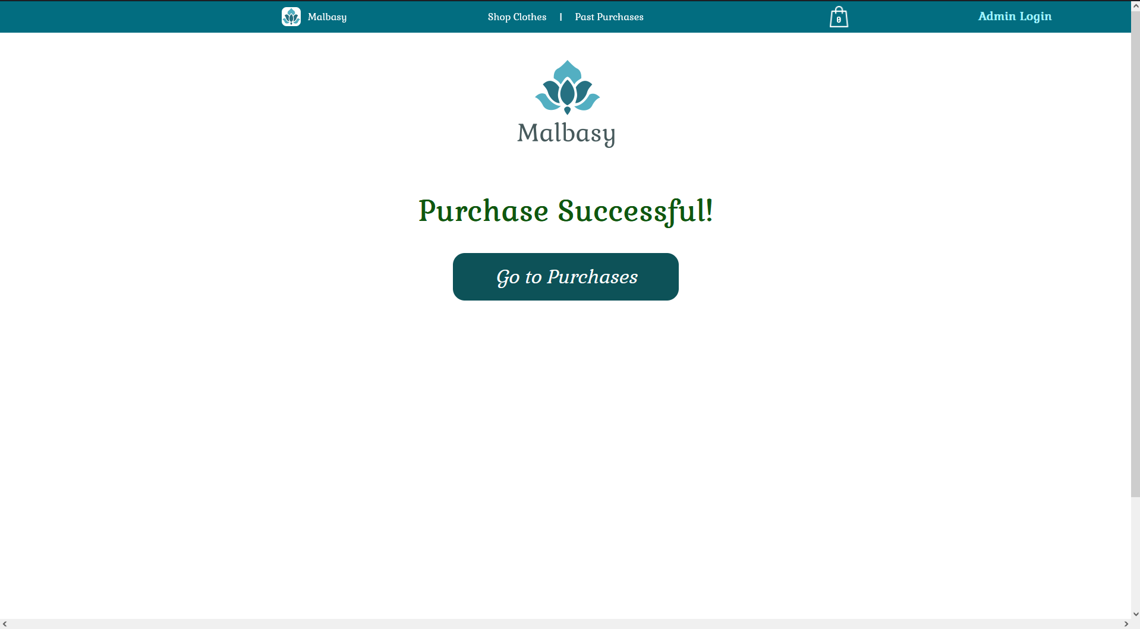

**Past Purchases:**

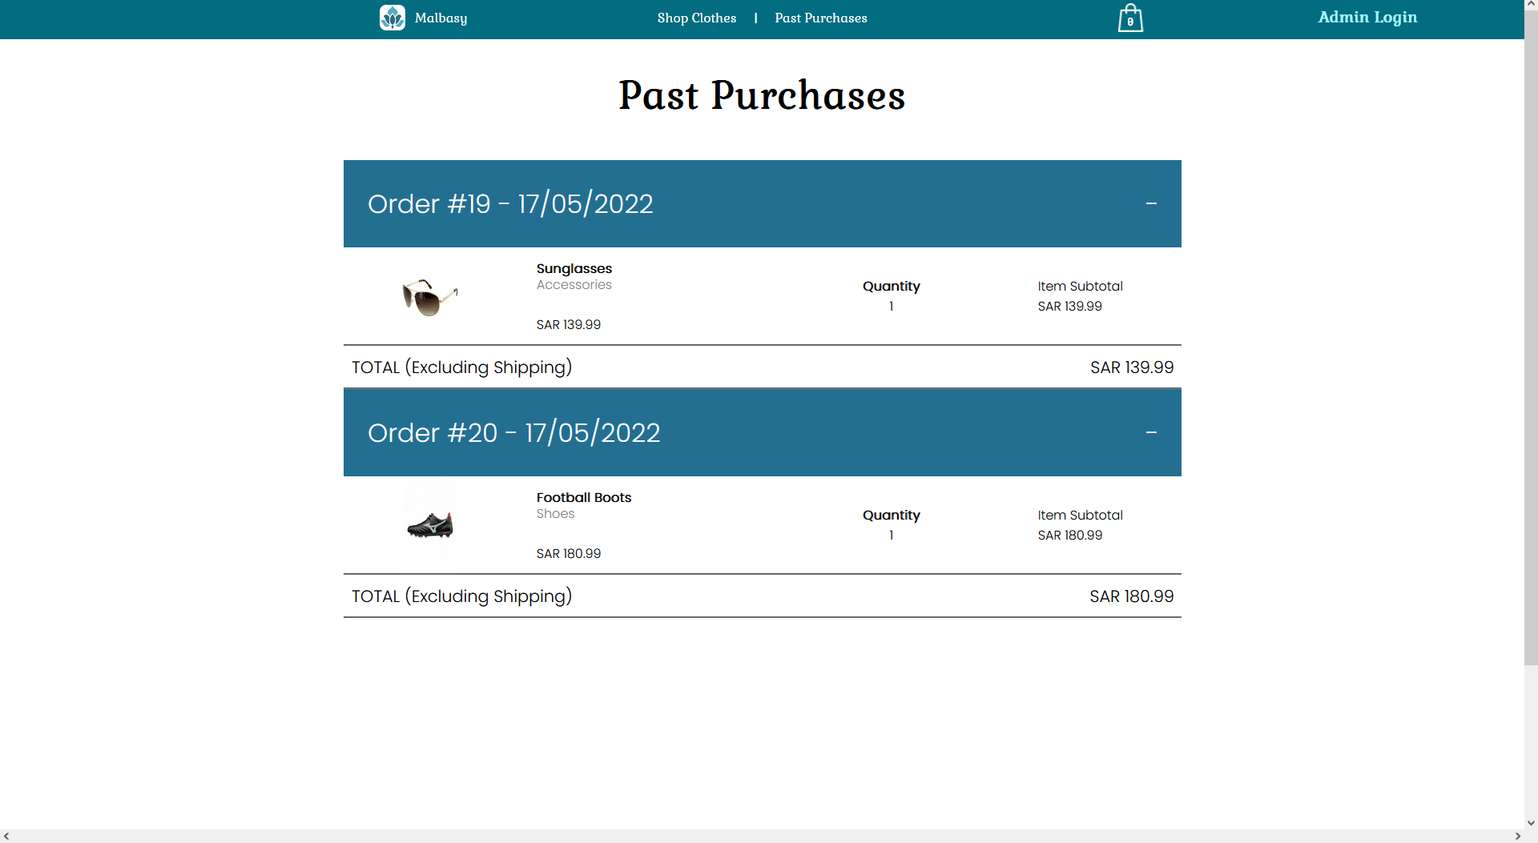

**Admin Login:**

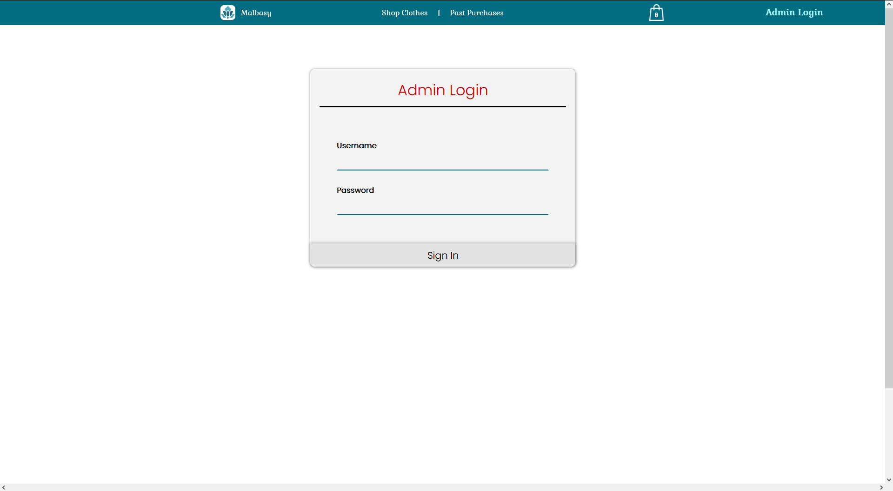

**Admin View (Edit/Delete products):**

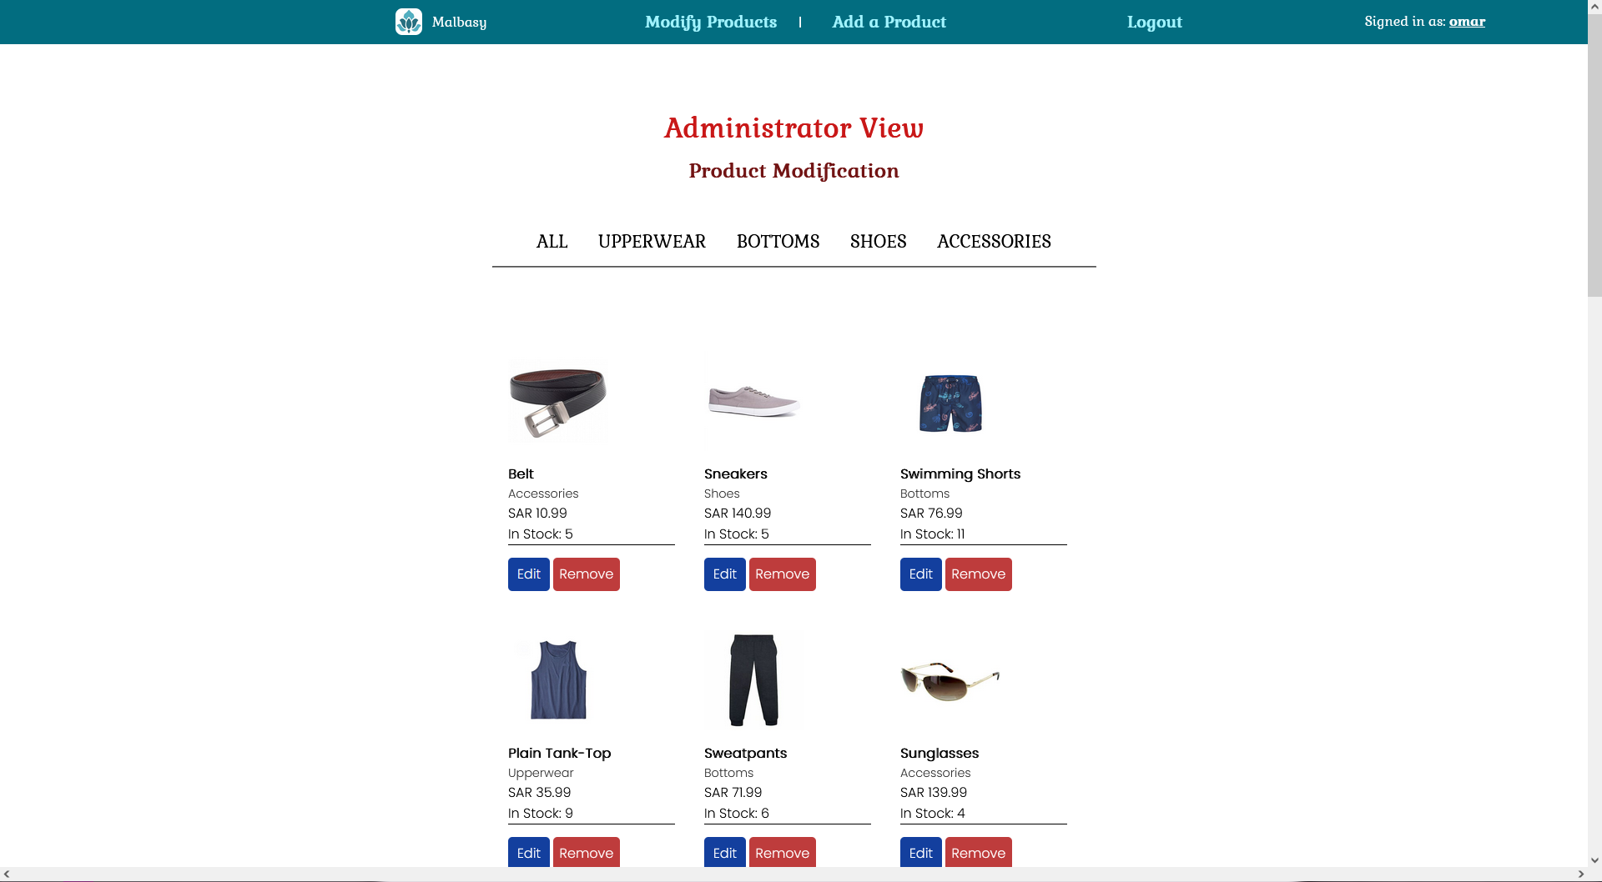

**Edit a product:**

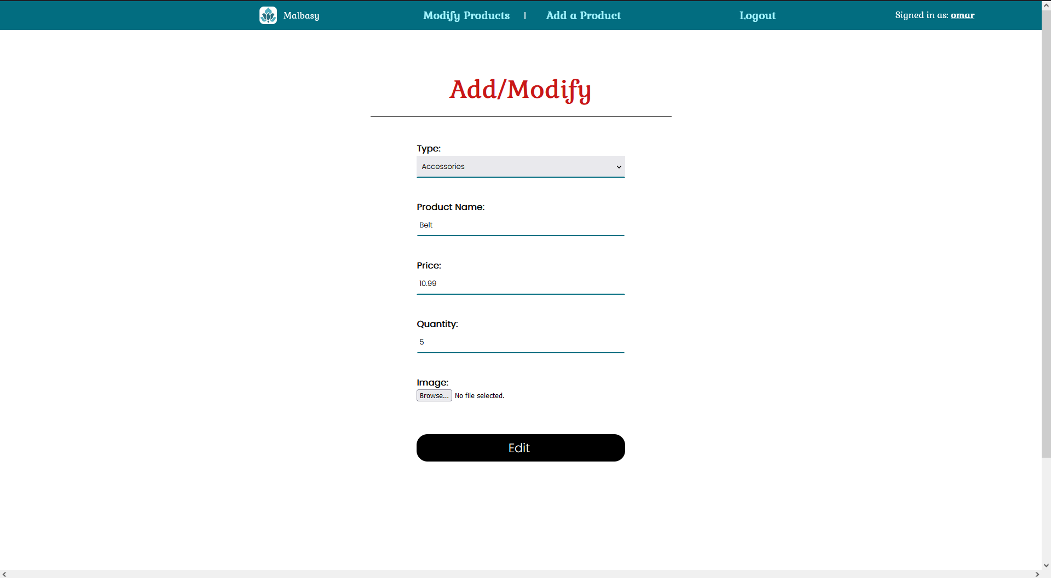

**Add a new product:**

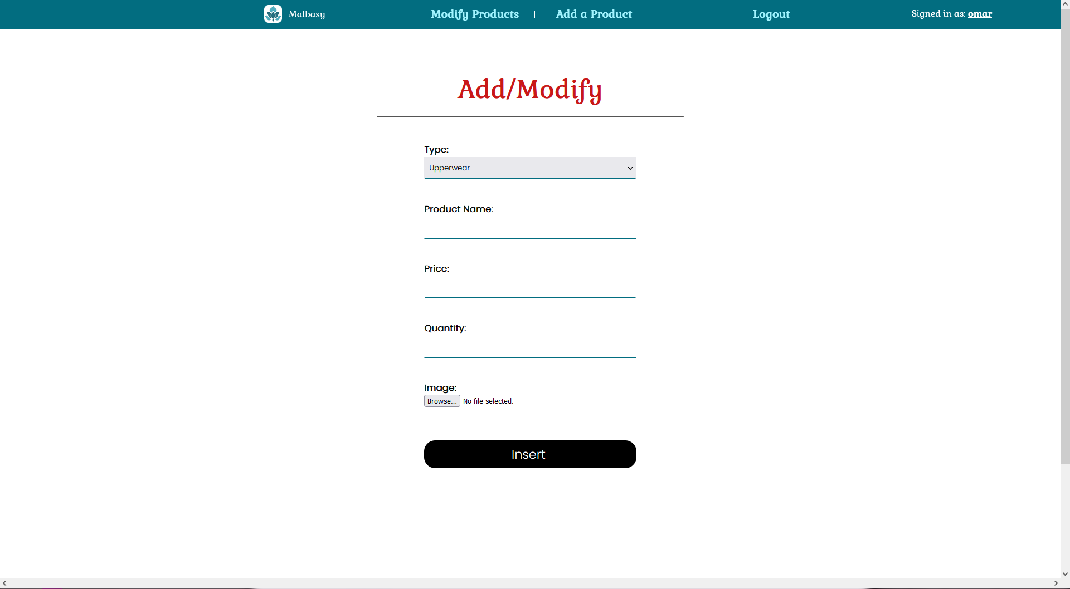

**Contact Us:**

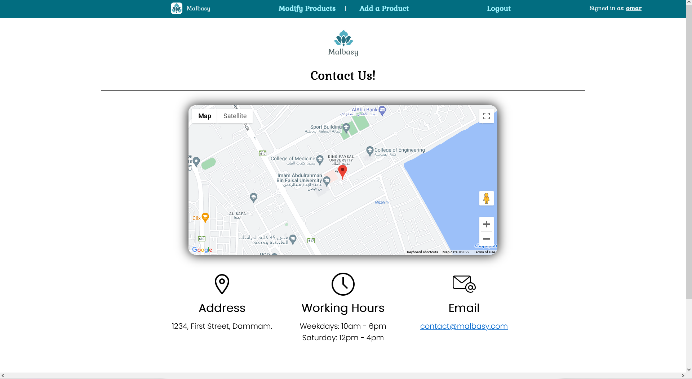

**Credits (For used icons):**

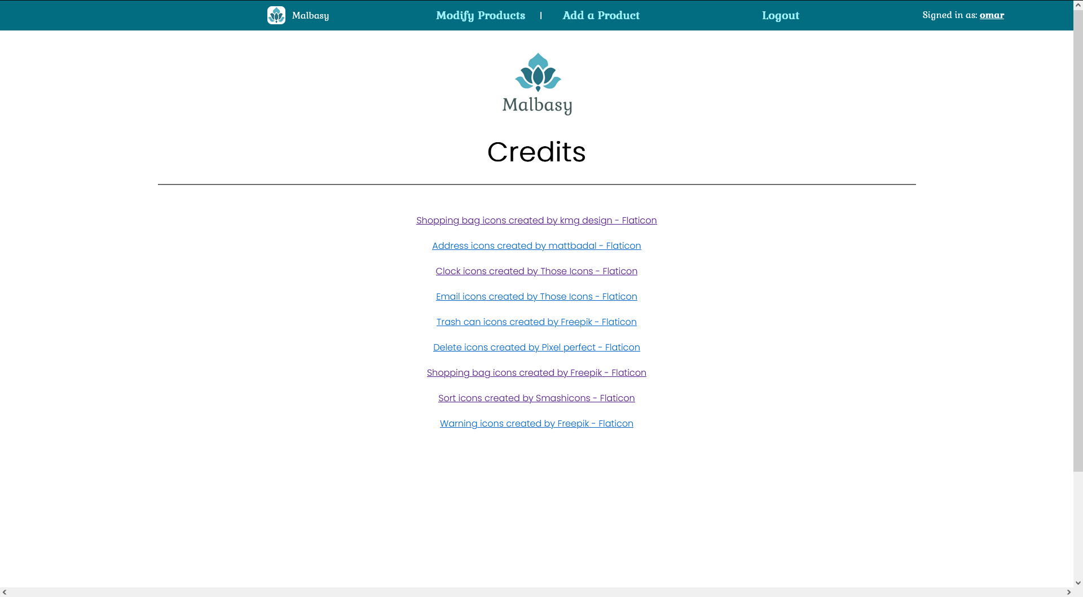

# Fulfilled Requirements

All tasks detailed in the main project document have been fulfilled. Some tasks might not be exactly as described due to them having been slightly altered by the course instructor.